15.46: a) For the fundamental mode, the wavelength is twice the length of the string, and b) The frequency of the fundamental mode is proportional to the speed and hence to the square root of the tension; 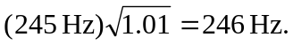 c) The frequency will be the same, 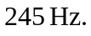The wavelength will be which is larger than the wavelength of standing wave on the string by a factor of the ration of the speeds.

